McKnight/John Laurie Intersection Meeting
North Haven Community Association
2017-09-07

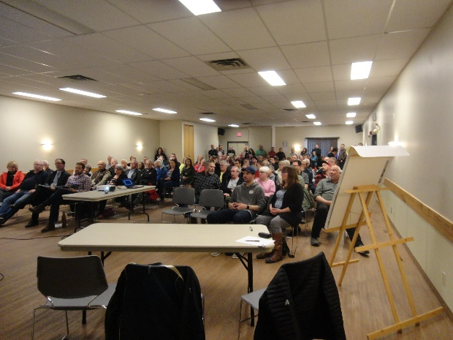

Meeting Record

The attendance log has 65 names.

This is a summary of the main issues. Notes of the detailed questions and comments are available.

- Bob Porteous introduced the purpose of the meeting which was to provide the community with a progress report.

- Naveed Butt, Travis Gaede and Tony Churchill with City of Calgary Transportation Engineering divisions provided a presentation. This is separately provided on the website.

- Short Term improvements:
- Make pedestrian crossing safer by increasing the flashing lights to make more visible especially when there is sunlight glare in motorists’ eyes.
- Additional approach signs will be provided.
- Chevrons or some form of marking is being considered for the turn. Residents cautioned that this should not reduce visibility for the yield through lane.
- Traffic Engineering at The City has these lower cost improvements (a, b and c above) at the top of the list of items that can be done by crews if there is any gap time in their work schedule.
- Six options have currently been prepared for short term improvements (not presented).
- All six options include two universal items:
  - A pathway connecting Egert Park with the McKnight/48 Ave NW intersection
  - Blocking of northbound left turn from John Laurie to 48 Ave NW
- Some of the community members requested to consider the following in the short-term upgrades:
- A path on the north side of 48th to lead away from the intersection.
- Consider installing vehicle detector if traffic signals are installed.
- Naveed Butt advised that The City is considering options to improve traffic flow in the McKnight Blvd corridor between 4th St NW and Edmonton Trail NE. In the meanwhile, The City is considering six options, one of which includes installation of traffic lights at John Laurie Blvd intersection. However, there will be impacts of installing the lights which will be considered when evaluating the options.
- Eliminate the northbound left turn movement at John Laurie Blvd and 48 Ave intersection. There is a very low turn volume and the turn confuses circulation. One person asked if it was possible to have removable barriers in case the other access point on 14th was temporarily blocked.
- Consider increasing the storage lane for eastbound traffic north of the eastside traffic island.

- Long Term plan:
- The intersection is currently connected to the upgrade of McKnight to Deerfoot. The history of the project was reviewed. The current estimate is $71M. This will be prioritized with all other transportation projects for the next 10 year capital program.
- If this again does not achieve funding, residents will request a stand alone safety project with a lower design speed.
- Residents expressed concern that increasing density such as along Centre Street and in Highland Park will result in our intersection becoming increasingly dangerous.

Our community overwhelmingly describe this intersection as dangerous but it is statistically ranked as having a low record of accidents. This perceptual gap is technically known as human factor risk compensation.

The Development Review Committee will be meeting with City Transportation in October and the recommended short term improvements will be presented to the NHCA Board on November 9th. The recommendations will be presented to the community for final comment in January.

Residents expressed their appreciation for the presentations and discussions.

Terry Arnett
Director, Civic Affairs

Subsequent to the meeting, NHCA formed a pathways committee to separately articulate the bicycle and pedestrian path locations throughout the community.

